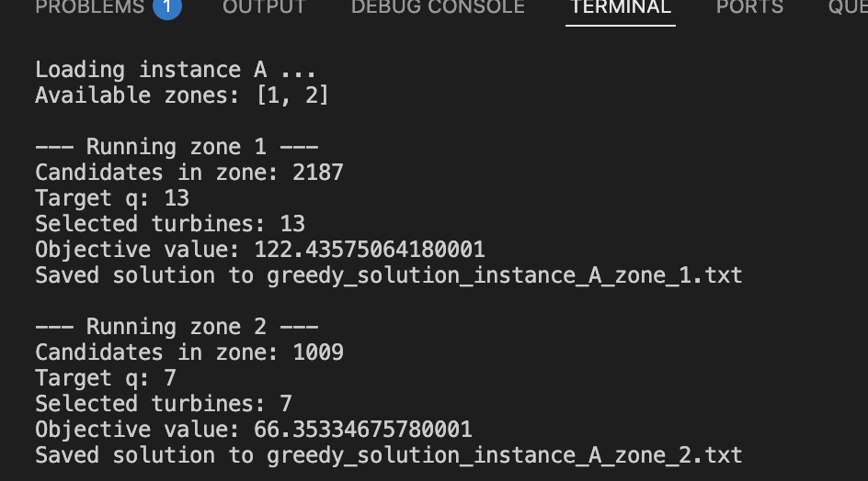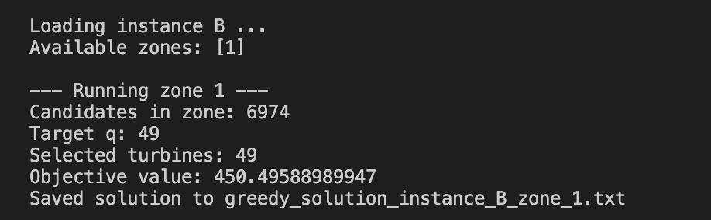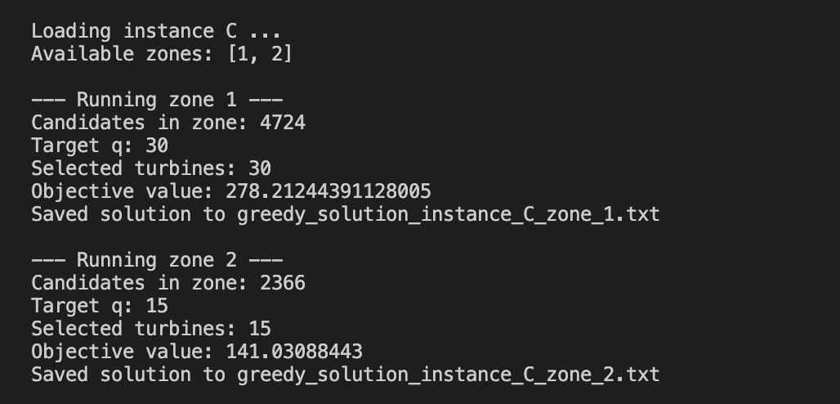
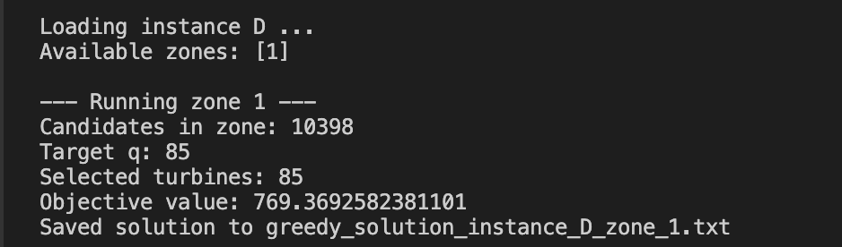
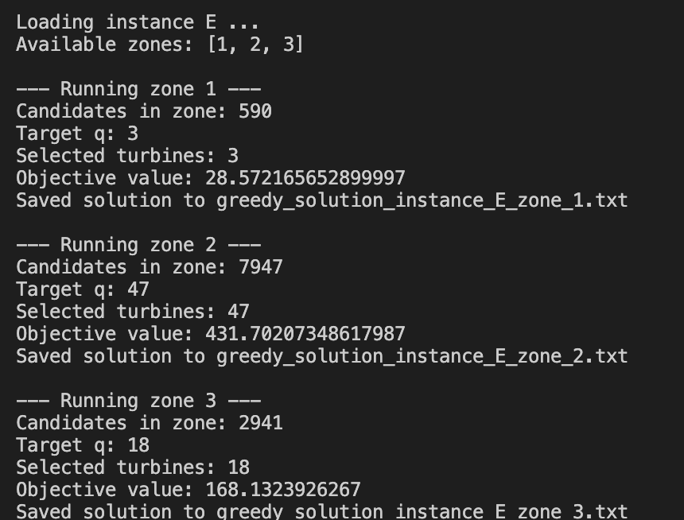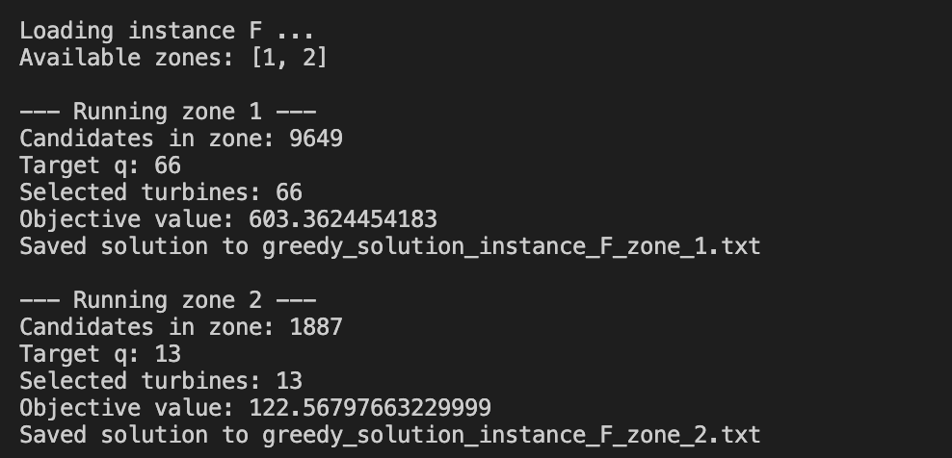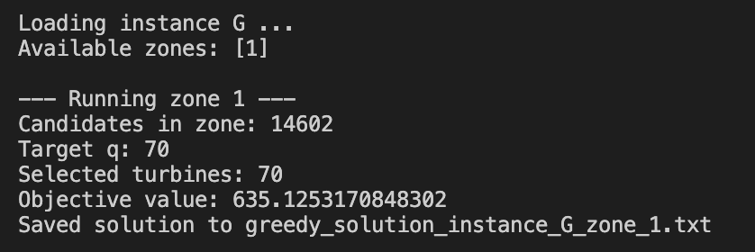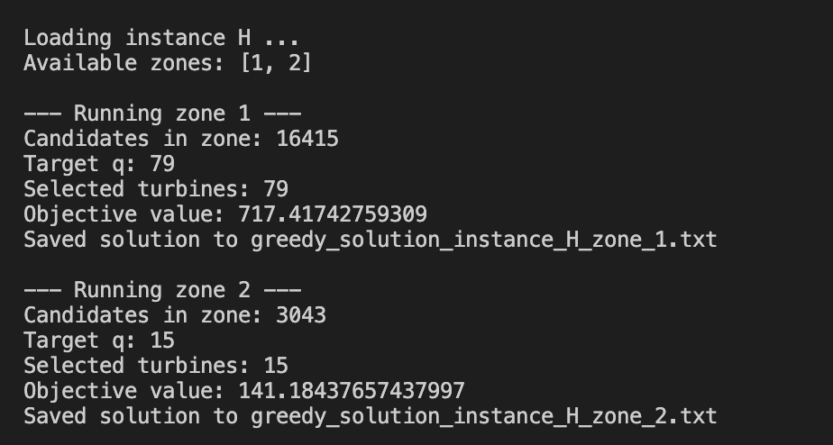
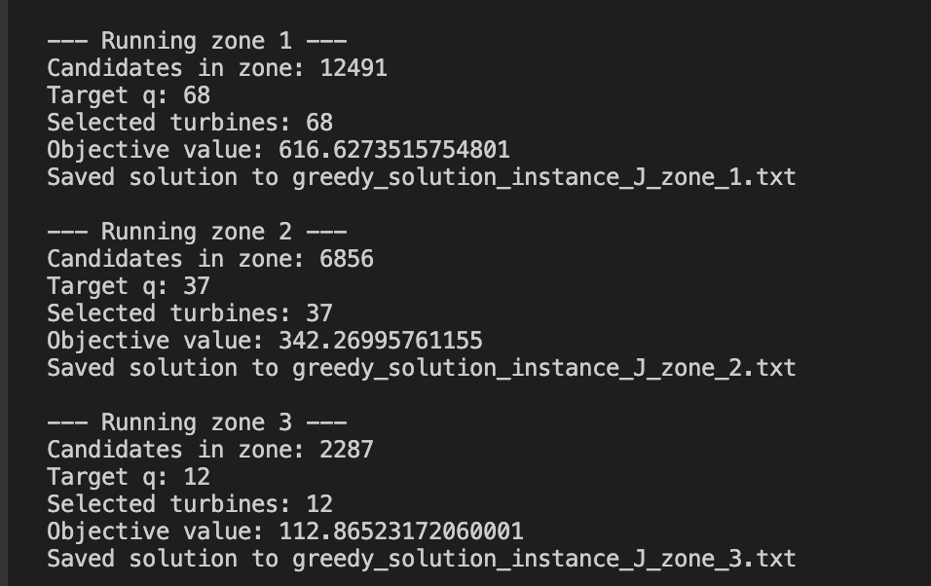
function parse_args()
instance = length(ARGS) >= 1 ? ARGS[1] : "J" #HERE YOU CAN CHANGE INSTANCE ################################################
zone = length(ARGS) >= 2 ? parse(Int, ARGS[2]) : 1
return instance, zone
end

